ALMA Design Study Flask Back End Project

# Atacama Large Millimetre/submillimetre Array

ALMA is an astronomical interferometer of radio telescopes in the Atacama Desert of northern Chile. Since a high and dry site is crucial to operations of radiation at millimeter and submillimeter wavelengths, the array has been constructed on the Chajnantor plateau at an elevation of 5,000 m (16,000 ft), near Llano de Chajnantor Observatory and Atacama Pathfinder Experiment. Consisting of 66 radio telescopes with diameters of 12 m (39 ft) and 7 m (23 ft), which observe radiation at millimeter and submillimeter wavelengths, ALMA is expected to provide insight on star birth during the early universe and detailed imaging of local star and planet formation.

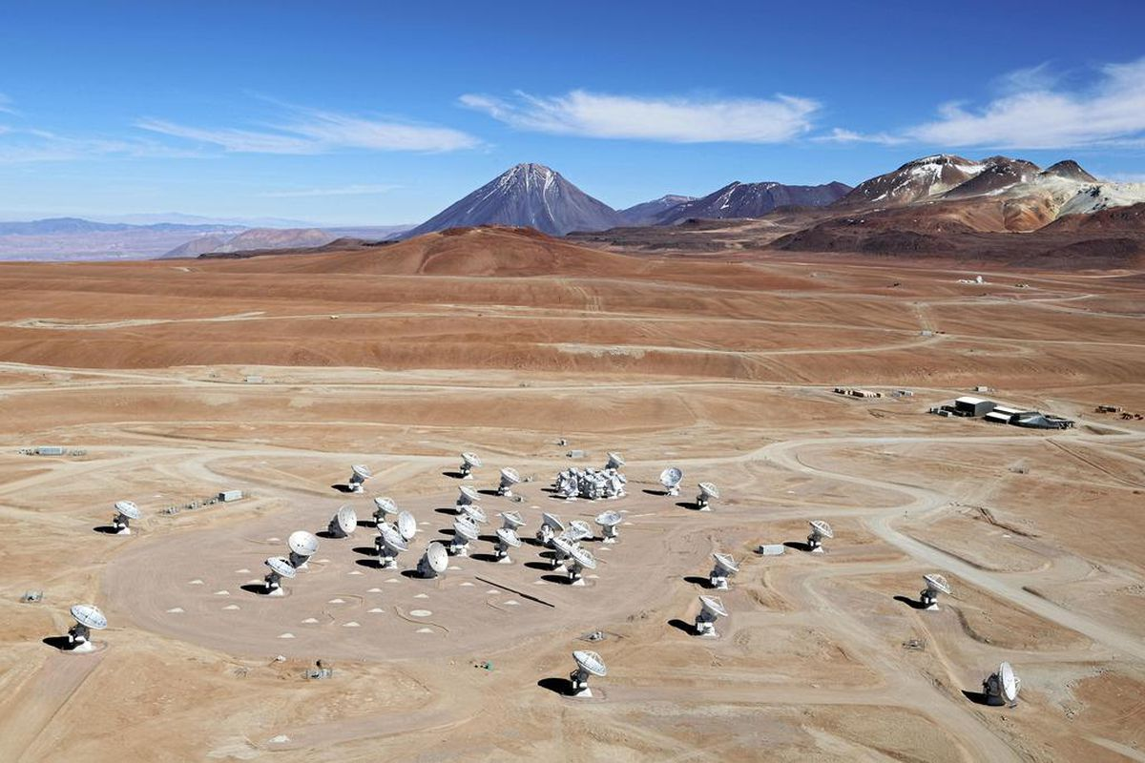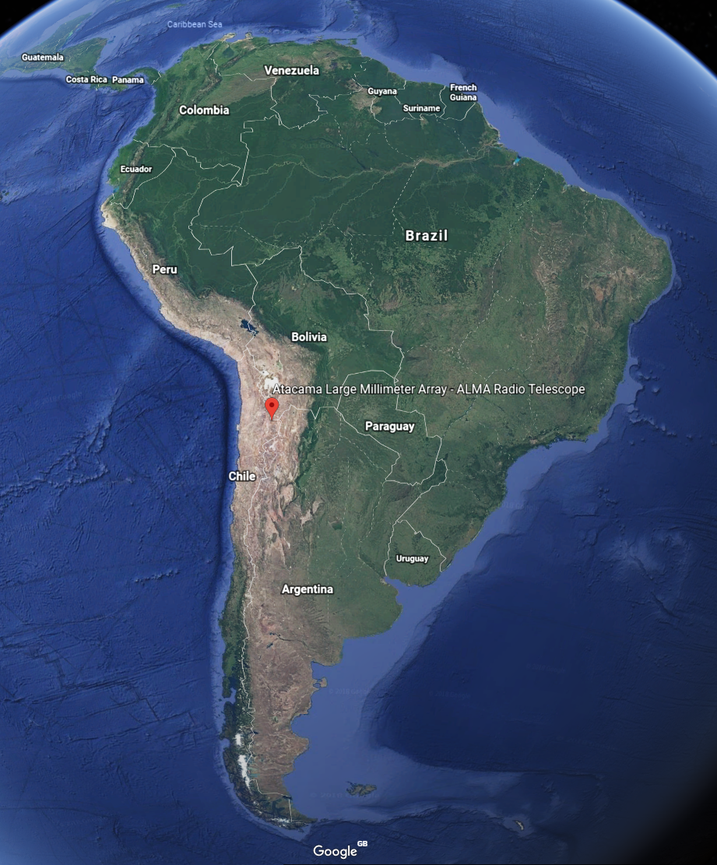

# Observation Tool Design Study

The ALMA Observatory aims to make observing easy for end-users and to ensure that it is open to the entire astronomy community. A key part of this aim is the ALMA Observing Tool (OT), which ensures that proposal and observing preparation for ALMA are as simple as is possible. In the age of the web, tablets and smartphones, of cloud computing and storage, and with internet access almost universal the way people interact with computers is changing rapidly. To remain “easy to use” in 5-15 years time the ALMA Observatory must evolve to keep pace with these changes. As the Observatory’s main user interface to the astronomy community the ALMA OT must be at the forefront of this evolution. Furthermore, as software technologies continue to evolve rapidly the technological context in which the tool resides changes, rendering some of its components obsolete and expensive to maintain.

The purpose of this study is to review the current state of the OT and propose development work to make it ready for ALMA in the 2020-2030 timescale. The study will evaluate the current usability and the technologies used by the tool in the future context of observing with ALMA, and identify the best approaches to updating and improving the tool meeting current and future requirements.

# Project Outline

A prototype of a web based OT is in development as a method determining the suitability of these new technologies. To save re-inventing the wheel, the RESTful back end server for this prototype has been written in Java to allow reuse of the current OT’s source code but to investigate more technologies, a Python/Flask version or individual service is required.

Creating a Flask version of the Spectral Service has been identified as a good starting point as this service is simple, with only two REST endpoints, and does not rely on any other service. The purpose of this service is to provide data to the spectral visualiser in the web client in the form of integer arrays and some objects.

## Outcome

The outcome of this project is a Flask version of the spectral service which can easily replace the current Java version. This service should maintain the current REST endpoints and ideally be containerised using Docker.